Mobile Devices and Self-Service e-Commerce
Student’s Name
Professor’s Name
Course Title
August 25, 2016

Mobile Devices and Self-Service e-Commerce
The e-Commerce start-up organization Sports R US is to give an advantageous self-administration answer for clients getting to games products. The Web application should be accessible on cell phones. The application moreover requirements to chip away at numerous Web programs (i.e. Chrome, Firefox, Web Explorer, Safari and others to bolster self-administration assignments. Sports-R-US has requested that you give a “Human-Computer Interaction” (HCI) attendant for the plan and implementation of service.
- Information Gathering
The information gathering is a process of collecting the data about a particular topic. There are different approaches to assembling input, and the techniques you utilize will rely on upon what results you are searching. When you unmistakably characterize the data you require, plan a method and inquiries that will help you recover that data. The information gathering procedures make it less demanding to decide why individuals purchase your items. The more information you have, the more you build your odds on making your product a win (ournonprofitalliance).
- Design Strategy
There truly is nobody meaning of design strategy, yet the objective is to union business and imaginative targets seriously that moves outline past only a tasteful activity. It could portray as developing the dialect to express your customer's business technique unmistakably. It is a dimensional, multifaceted arrangement that permits going down various paths are a dimensional, multidimensional method that allows going down different ways. It’s the means by which we prescribe drawing closer the task; creative brief edges what ask for by the customer and is a fundamental piece of correspondence amongst customer and designer.
- Prototyping
Prototyping is the way toward building a model of a framework. As far as a data framework, models are utilized to help framework fashioners fabricate a data neteork that natural and straightforward to control for end clients. Prototyping is an iterative procedure that is a piece of the examination period of the frameworks advancement life cycle. The customer input picked up from building up a physical framework that the clients can touch and see encourages an evaluative reaction that the expert can utilize to alter existing prerequisites and also growing new ones (umsl).
- Implementation
Implementation is the completing, execution, or routine of an arrangement, technique, or any configuration, thought, model, particular, standard or approach for accomplishing something. Like this, implementation is the activity that must take after any preparatory deduction with the end goal something should happen. In the expansion, the movement or system actualize is depicted in adequate detail so that free onlookers can identify its nearness and quality.
1. Mobile Services
- There's more than one approach to come to the “mobile” shopper, who may like to call, content, use a portable application or site, or cooperate using online networking. Take the full favorable position of the force and omnipresence of today's cell phones to enhance client reliability, improve administration, lessen contact focus expenses and increase upper hands. An application or the web outlined and adjusted to the particular components of mobiles and tablets is an absolute necessity for any business today. Not just is Mobility an idea securely attached from higher income for any organization, additionally client experience, and fulfillment. To this end, we concentrate on mobile devices as client organization association channels, growing completely coordinated corporate applications that empower self-administration of customer inquiries and operations (Jacko, 2011).
- It characterized target audience is fundamental for the achievement of each publicizing effort. Besides, when during the time spent arranging a mobile campaign, it is critical to think past the known sociological parameters and spotlight on comprehension the individual qualities of the objective gathering. A self-service mobile stage for little organizations, Sports R US to permits clients to target customers inside finished edges around their stores with versatile presentation advertisements that dispersed over various famous mobile applications and destinations. Publicists have complete control over the look and feel of their publications, and they can confirm the message or the planning to support ROI whenever.
- What audience of people needs and needs from mobile self-services it would be the applications that are made to use in the wake of utilizing the desktop adaptation of the site. What the understudies of Oxford University will require from this administration is to get to the advancement of their degree, grades, old evaluations or classes.
- The properties that are important to accomplish the needed yield control by the particular way that Oxford University will use to perform the versatile web application. Some mobile applications require specific programming dialect programs and the need to send the portable application to a mobile application store.
- The across the board organization of Web-empowered mobile devices settle on them an objective of decision for substance makers. Understanding their qualities and their constraints, and utilizing advances that fit these conditions are vital to making achievement versatile well-disposed Web content. Mobile devices have entirely various equipment attributes contrasted and desktop or PCs. Their screens are typically littler, clearly; however they likewise for the most part consequently switch the screen introduction amongst representation and scene mode as the client pivots the gadget. They ordinarily have touch screens for customer info. APIs like relocation or opening are either not bolstered on desktops or are a great deal less valuable, and these APIs give portable clients better approaches to associate with your site (w3, 2016).
- A mobile user interface is graphical and more often than not touch-delicate showcase on a cell phone, for example, a mobile phone or tablet that permits the client to cooperate with the gadget's applications, components, substance, and capacities. In a mobile interface, images might utilize all the more widely and controls might consequently cover up until got to. Mobile devices are strongly individual. They are our consistent allies. Applications that well disposed of, reliable and fun are a joy to utilize, and people will turn out to be very joined to the experience.
Every stage characterizes its particular visual style through shading subjects, symbol styles, analogies, and gadget rendering. The utilization of an optical stage topic is more than a tasteful decision. Stage themes set up client desires that customer collaborations in the application will take after stage traditions. By definition, portable web applications keep running in versatile web programs. Similarly, as with the desktop web, the program displays an extra layer of user interface around the web application. What's more, again like the desktop web, route issues emerge when the client has entry to route controls inside the application and also in the program. Whenever possible, run your application in booth mode and give all fundamental route within the application.
2. Sports R US
- Sports R US home page
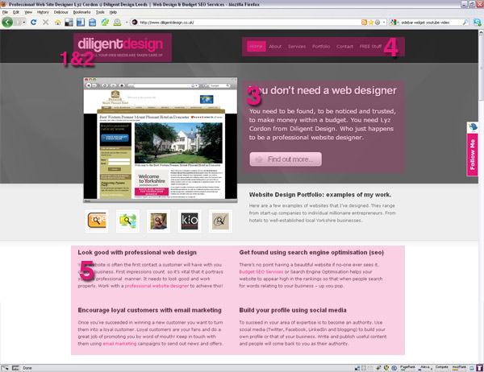

- Self- Services Webpage
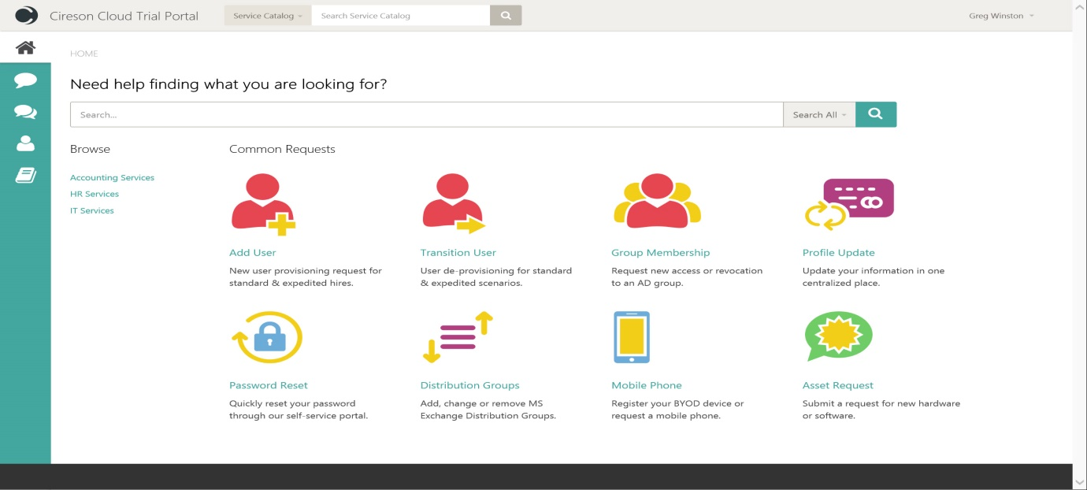
3. Making a prototype can likewise be a standout amongst the best time and compensating steps you'll take. That is on account of building up a prototype gives you the chance to take advantage of your innovativeness truly, utilizing those skills that roused your development thought in any case. Making a prototype by hand is an awesome approach to begin breathing life into mobile (Unhelkar, 2005).
The Prototype design indicates the sort of items to make utilizing a prototypical occurrence. Models of new items regularly work before full creation, however, in this case, the model is aloof and does not take an interest in duplicating itself. The mitotic division of a cell - bringing about two indistinguishable cells - is a case of a model that assumes a dynamic part in duplicating itself and in this manner shows the Prototype design. At the point when a cell parts, two cells of indistinguishable genotype result. At the end of the day, the cell clones itself.
4. There are a lot of awesome tools accessible to help you test and assess the user experience on your site. UserTesting offers a wide assortment of administrations for testing your user’s experience. You'll be able to pick the client profiles that you'd like to study, and they even offer an administration for you to see an on-going video of test members utilizing your site or application. A business sector pioneer in client testing, ClickTale permits you to watch video playback of how users experience your site on both desktop and mobiles.
Usabilla testing tools permit you to test both change and client experience. With nine individual applications that you'd pay for independently, Usability Tools permits you to get to a client research board, make criticism frames, record guest action, test web structures and that's only the tip of the iceberg. Make interactive, intuitive models effortlessly utilizing InVision's impeccably straightforward apparatus. Utilizing InVision, you'll change level arrangements into all the more vivacious models. Besides, they make it basic for you or your customers to see the models on a mobile or desktop. For fast, interactive prototyping, Pidoco is an incredible tool. With a simple-to-use interface and sharing and joint effort highlights, Pidoco makes it easy to make a whole site, get input and test your outline before dispatch (Marcus, 2011).
With wireframing programming for both sites and mobile applications, MockFlow is an extraordinary answer for those hoping to outline adaptable user interfaces. Contingent upon your necessities, this system, offers singular instruments for site plan, site building, and group coordinated effort. A surely understood presentation page and site test programming, Optimizely does it all. You can utilize this project to alter your hues, pictures, and content, plan your tests and quickly convey the triumphant arrangement. Multivariate testing is additionally accessible through Optimizely for more propelled advertisers.
5. Mobile services and end-client gadgets have been quickly developing in advancement, expanding the bolster costs for administrators and promoting dissatisfaction for clients. The administrators have begun putting resources into multi-channel client care stages and also implementing progressively complex portable self-services arrangements and have accomplished diverse levels of development and modernity. They have additionally balanced their IT frameworks to bolster connection client applications for insightful gadgets, for example, cell phones, and tablets, and have incorporated long range informal communication advancements into their operations (Czernicki, 2011).
With the end goal clients should embrace mobile self-service, administrators need to advance that channel: those administrators that have accomplished high appropriation rates have utilized refined crusades to advance the self-administration channel. A regular mindfulness crusade utilizes SMS and IVR suggestions to advance the self-administration channel, and a few administrators likewise offer motivating forces to clients to trial the new administration. Organizations ought to gladly oblige because insights on the organization advantages of self-administration additionally are clear and convincing. The examination predicts that by 2016, no less than 80 percent of associations that neglect to arrange their self-administration executions. It will bring about higher client administration costs and won't accomplish the investment funds and advantages expected. Accenture has found that a common utility can spare between $1 million and $3 million by actualizing self-service (Bartz, 2015).

References
Bartz, R. J. (2015). Mobile Computing Deployment and Management: Real World Skills for CompTIA Mobility+ Certification and Beyond.
Czernicki, B. (2011). Silverlight 4 Business Intelligence Software.
Jacko, J. A. (2011). Human-Computer Interaction: Towards Mobile and Intelligent Interaction Environments: 14th International Conference, HCI International 2011, Orlando, FL, USA, July 9-14, 2011, Proceedings.
Marcus, A. (2011). Design, User Experience, and Usability. Theory, Methods, Tools and Practice: First International Conference, DUXU 2011, Held as Part of HCI International 2011, Orlando, FL, USA, July 9-14, 2011, Proceedings, Part 2.
ournonprofitalliance. (n.d.). Information Gathering Methods. Retrieved from ournonprofitalliance: http://www.ournonprofitalliance.org/evaluation_gathering.aspx
umsl. (n.d.). What is Prototyping? Retrieved from umsl: http://www.umsl.edu/~sauterv/analysis/prototyping/proto.html
Unhelkar, B. (2005). Verification and Validation for Quality of UML 2.0 Models.
w3. (2016). MOBILE WEB. Retrieved from w3: https://www.w3.org/standards/webdesign/mobilweb

